|  |  |  |
| --- | --- | --- |
| Project Settings: <https://drive.google.com/open?id=1bIWSzxDlhNRyUOUX_9wq728ZlzKtD0T2mv1hEl6MYnA>  Please view project settings before start | | |

1. **Task Requirement / Description**
2. **Navigate to Task Area**
3. **UI Example**
4. **Programming Logic**
5. **Database**
6. **Changes to Commit ( developer to complete )**
   1. **Files / Folders to add to live site**
   2. **Database Changes to add to live site**
   3. **Developer notes / instructions for Project Manager**

**1. Task Requirement / Description**

Customer wants to add a list of links to the side of the category image

* Please add box to right side of image
* Please add a table to the admin area to add and remove links

**2. Navigate to Task Area**

Front end

1. Front page
2. Click “See More” button for pipes banner on front page
3. Add a yellow box under pdf + youtube links if the category have any links
4. If there is no big image for category then do not show any links box

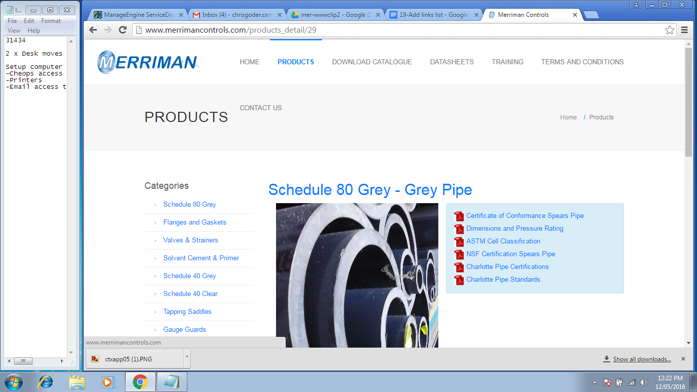

Admin site

1. Add option to action menu for category manager to “Edit Sales Points”
2. Direct user to a modal page or new page with a table where user can enter a link name, link address delete link.

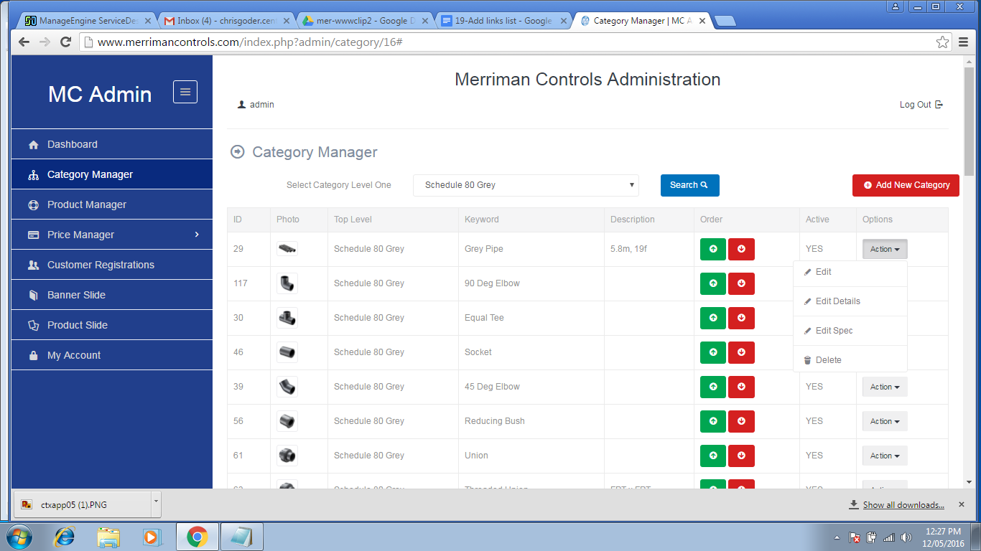

**3. UI Example**

I will update later

**4. Programming Logic**

Front End

1. If there is no product image then do not show links
2. If there is product image then show links relating to category in a yellow box like pdfs showing link name as a clickable link that opens in new page

Admin

1. When open page / modal window get links relating to category
2. Show links in a table with option to remove
3. Add form to top of table to add a new link name and link address

**5. Database**

Add a table for category_links

* linkId
* categoryId
* linkName
* linkAddress

CREATE TABLE `category_links` (

`id` bigint(20) unsigned NOT NULL,

`cateid` bigint(20) unsigned NOT NULL,

`linkName` varchar(255) DEFAULT NULL,

`linkAddress` varchar(255) DEFAULT NULL,

PRIMARY KEY (`id`)

) ENGINE=InnoDB DEFAULT CHARSET=latin1;

**6. Changes to Commit ( Developer to Complete section 6a, 6b, 6c)**

This section is to help the Project Manager update the test site and live site. Please fill in the below area’s 6a, 6b and 6c, this is to inform the Project Manager as to what changes were made and needed to add update the live site

**6a. Files / Folders to add to live site**

Please add to the below table a list of files or folders that the Project Manager will need to upload to the live site.

|  |  |  |  |
| --- | --- | --- | --- |
| Folder Name: |  | | |
| File Name | File Name | File Name | File Name |
|  |  |  |  |
|  |  |  |  |
|  |  |  |  |

|  |  |  |  |
| --- | --- | --- | --- |
| Folder Name: |  | | |
| File Name | File Name | File Name | File Name |
|  |  |  |  |
|  |  |  |  |
|  |  |  |  |

|  |  |  |  |
| --- | --- | --- | --- |
| Folder Name: |  | | |
| File Name | File Name | File Name | File Name |
|  |  |  |  |
|  |  |  |  |
|  |  |  |  |

**6b. Database Changes to add to live site**

Please add below any db changes or db script code the Project Manager will need to add to the live site database

**6c. Developer notes / instructions for Project Manager**

Please add here any instructions for the Project Manager to follow for updating the live site

Eg. 1. Please run db script

2. Please insert new data to db

3. Then update files in live site

**END**